**CS 419 Compiler**

**Project Form**

**Project Idea:**

……project 3……………………………….

**Team Members NO#:** …………………………………..

|  |  |  |  |  |  |
| --- | --- | --- | --- | --- | --- |
| **ID** | **Name** | **Level& Department** | **Section(Dayfrom-to)** | **Role (Lead/Member)** | **Grade** |
| 201900959 | ياسمين عادل نصر غانم | 3 cs |  |  |  |
| 201900012 | ابراهيم محمود مكي حسين | 3 cs |  |  |  |
| 201900437 | عبدالرحمن محمد فكري ثابت | 3 cs |  |  |  |
| 20180142 | إيثار طارق عبد العزيز | 4 cs |  |  |  |
| 201900984 | يوسف شعبان إمام | 3 cs |  |  |  |
| 20180689 | ياسمين محمد حسن | 4 cs |  |  |  |
| 201900496 | عماد علي عماد حافظ | 3 cs |  |  |  |

**Regular Expression, Finite automata and Conversion from RegX to NFA, NFA to DFA**

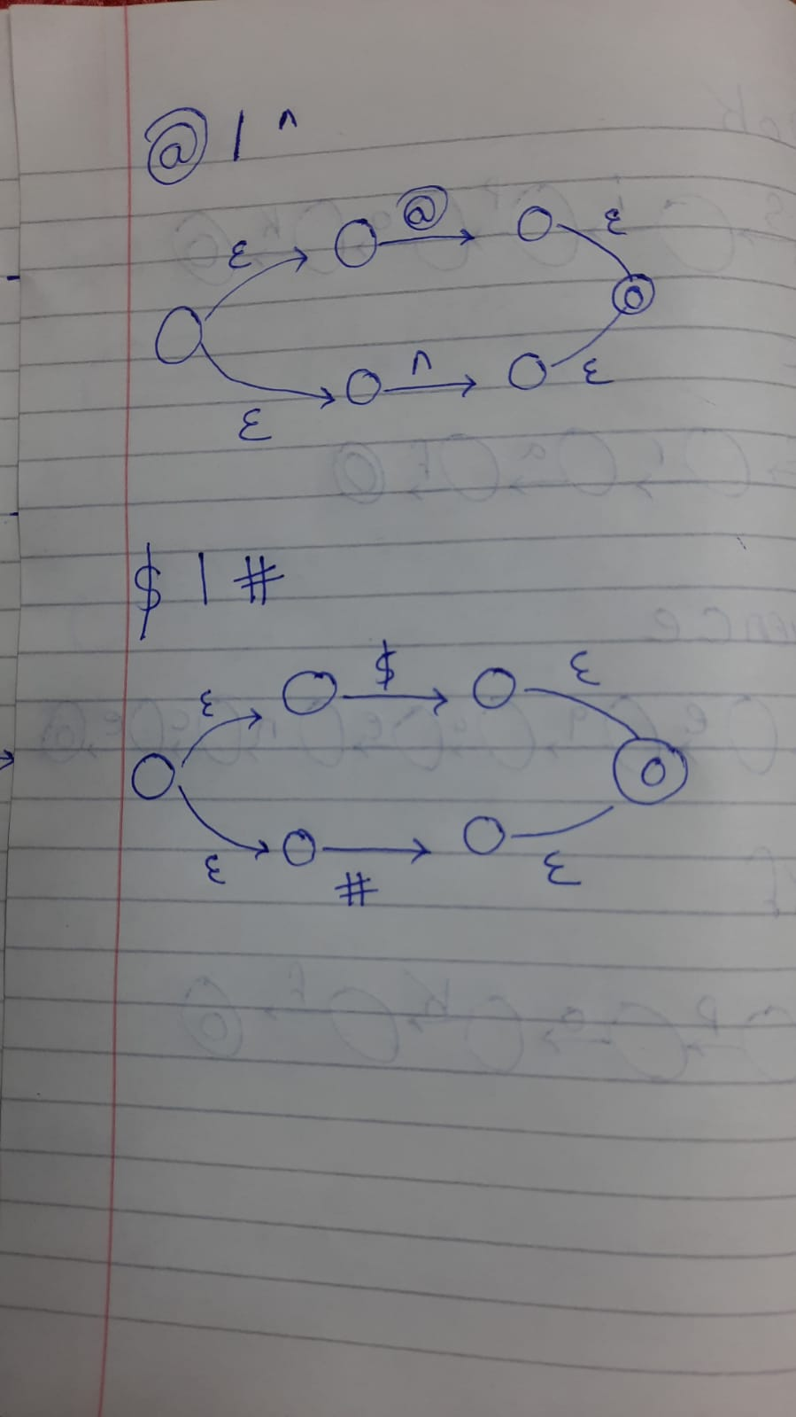

**Parse tree and Abstract syntax tree**